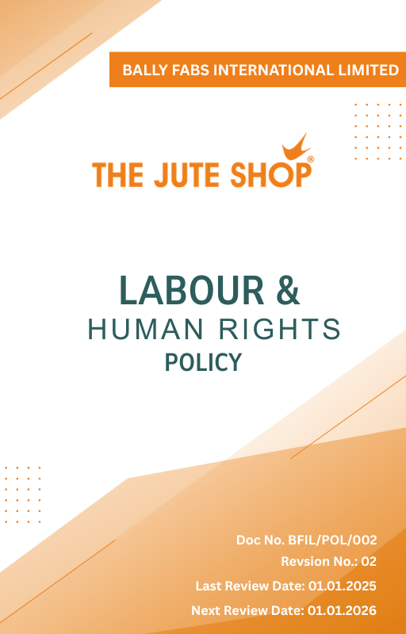
Contents

Introduction 3
Policy Declaration 3
Scope 4
Key Focus Areas 4
Qualitative Objectives 5
Quantitative Targets 6
Alignment with the United Nations SDGs 8
Responsibilities 8
Monitoring, Reporting, and Transperancy 9
Review Mechanism 10
Employee Acknowledgment Form 11

Introduction
Ballyfabs International Limited is committed to upholding the highest standards of labor and human rights across all aspects of our operations. Our policy reflects a strong dedication to creating fair, safe, and respectful working conditions for all employees, partners, and stakeholders. We recognize that our workforce is central to our success, and therefore, we strive to foster an environment where every individual is treated with dignity, equality, and respect, and where their fundamental rights are safeguarded at all times.
This commitment extends to ensuring compliance with national labor laws, international conventions, and recognized frameworks such as the International Labour Organization (ILO) standards and the UN Guiding Principles on Business and Human Rights. We place emphasis on eliminating child labor, forced labor, and discrimination, while promoting diversity, equity, inclusion, freedom of association, and fair wages. Through continuous monitoring, training, and collaboration with stakeholders, we aim to build a culture of accountability, ethical business conduct, and continuous improvement in labor and human rights practices across our value chain.

Policy Declaration
At Ballyfabs, we are steadfast in our commitment to upholding the highest standards of labor and human rights across all facets of our operations. Our Labor and Human Rights policy is designed to foster an environment where every individual is treated with dignity, respect, and fairness. This policy encompasses our dedication to equitable employment practices, the wellbeing and safety of our employees, open social dialogue, the elimination of child labor and forced labor, inclusion and equal opportunities, work-life balance, and continuous professional development.

Scope
This policy applies to all workers, employees, directors, officers, agents, contractors, and any third parties acting on behalf of Ballyfabs Int. Ltd. (BFIL). It covers all business activities, including procurement, sales, marketing, and any interactions with government officials, customers, suppliers, and other stakeholders. The policy is applicable globally, regardless of local business practices or cultural norms. This policy applies to the below-mentioned locations:

Site | Address
Bally Fabs International Limited | - 3, Haren Mukherjee Road, Belur, Howrah-711202, West Bengal, India.
Bally Fabs International Limited | - Vill-gangarampur, PO-Dakshin Alipore, ps-Bishnupur, Dist-South 24 Parganas, Pin-743503, West Bengal, India

Key Focus Areas
- Equitable Employment Practices - Ensure fair hiring, promotion, and compensation practices free from discrimination and bias.
- Employees’ Health, Safety and Wellbeing – Provide a safe and healthy working environment with appropriate working conditions and preventive measures.
- Collaborative Social Dialogue – Respect employees’ rights to freely associate and bargain collectively, fostering dialogue and collaboration.
- Child Labor, Forced Labor, and Human Trafficking – Prohibit all forms of child labor, forced work, and trafficking in our operations and supply chain.
- Inclusive Diversity and Equity – Provide equal opportunities and prohibit discrimination based on race, gender, age, religion, or other protected characteristics, promoting diversity, equity, and inclusion across all levels..
- Balanced Work-Life Integration – Promote a healthy work-life balance by implementing flexible working hours and remote work options.
- Comprehensive Career Development – Support skill development and equal opportunities for career growth.
- Discrimination and Harassment – Foster an inclusive workplace free from discrimination, harassment, or abuse.
- External Stakeholder Human Rights – Respect and protect the rights of communities, suppliers, customers, and other stakeholders.
- Working Conditions – Provide fair wages, reasonable hours, and respectful treatment for all employees.

Qualitative Objectives
- Equitable Employment Practices
- To build a fair and merit-based workplace where hiring, promotions, and compensation decisions are transparent, unbiased, and based solely on skills, performance, and potential.

- Employee Health, Safety and Wellbeing
- Foster a culture of safety-first mindset across all operations.
- Regularly enhance health and safety protocols to proactively address workplace risks and promote employee well-being and hence maintain zero absenteeism due to work-related injuries.
- Promote employee well-being through health programs and support systems.

- Collaborative Social Dialogue
- Foster open dialogue through structured communication channels and inclusive participation in workplace decision-making.
- Strengthen employee representation and participation in workplace decisions.

- Child Labor, Forced Labor, and Human Trafficking
- Enforce and maintain zero tolerance for child, bonded, or forced labor across all operations and suppliers.
- Strengthen supplier and partner due diligence on labor practices.
- Ensure strict monitoring and remediation mechanisms are in place.

- Inclusive Diversity and Equity
- Create opportunities for underrepresented groups in the workforce.
- Promote equal access to leadership and career advancement.
- Embed diversity and inclusivity into recruitment and retention practices.

- Balanced Work-Life Integration
- Encourage flexible and supportive work arrangements.
- Promote employee wellness through stress management and support programs.
- Ensure workloads are managed fairly to maintain productivity and well-being.
- Comprehensive Career Development
- Promote continuous learning through structured training, career planning, and periodic performance reviews.
- Foster a culture of lifelong learning and innovation.

- Discrimination and Harassment
- Ensure an inclusive, respectful workplace free of bias, discrimination, and harassment and hence maintain zero cases of harassment or discrimination.
- Strengthen grievance redressal mechanisms for fair resolution.

- External Stakeholder Human Rights
- Integrate human rights due diligence into business operations and key relationships to mitigate rights-related risks.
- Engage stakeholders to address potential or actual human rights impacts.
- Respect and safeguard the rights of local communities near operations.

- Working Conditions
- Promote a workplace culture that prioritizes ethical practices, psychological safety, and employee satisfaction.
- Ensure continuous improvement in workplace facilities and practices.
- Ensure working conditions compliance with global labor standards and local regulations.

Quantitative Targets
All targets outlined in the Labour and Human Rights Policy are based on the baseline data from year 2023. Progress will be evaluated annually, with the objective of achieving key milestones by year 2030, covering key areas such as employee well-being, ethical labor practices, inclusivity, fair compensation, and responsible partnerships.

- Equitable Employment Practices
- Achieve a 10% increase in workforce diversity by year 2030.

- Employee Health, Safety and Well-being
- Maintain Zero workplace accidents till year 2030.
- To increase safety inspections by 5% till year 2030 to proactively identify risks.
- Conduct 100% mandatory safety training for all employees yearly.
- Maintain zero fatalities across all operational sites.

- Collaborative Social Dialogue
- Ensure 100% of facilities have employee representation bodies by year 2030.
- Ensure 100% of employees have access to formal platforms to express concerns and feedback.
- Achieve 70% response rate in employee engagement activities by year 2030.

- Child Labor, Forced Labor, and Human Trafficking
- Conduct background checks for 100% of suppliers by year 2030.
- Train 100% procurement and recruitment staff on labor compliance policies annually.
- Maintain zero confirmed cases of child or forced labor till year 2030.

- Inclusive Diversity and Equity
- Increase representation of underrepresented groups in management by 15% by year 2030.
- Ensure equal pay audits conducted annually with 100% compliance.

- Work-Life Balance
- Offer flexible work arrangements for 100% eligible employees.
- Maintain absenteeism rate below 3% annually.

- Career Management and Training
- Conduct annual performance reviews and ensure career development plans are in place for 100% of eligible employees.
- Allocate 20% of the financial budget to employee development programs by year 2030.

- Discrimination and Harassment
- Conduct 2 workplace climate surveys on discrimination and harassment till year 2030 through survey forms filled by 100% employees.
- Provide mandatory anti-harassment and DEI training to 100% employees yearly.

- External Stakeholder Human Rights
- Ensure that 100% of supplier contracts include and comply with human rights clauses by the year 2030.
- Train 100% of procurement teams on human rights policies annually.
- Maintain zero reported human rights violations across operations.
- Conduct human rights impact assessments across operations annually.

- Working Conditions
- Conduct employee satisfaction surveys annually on working conditions, aiming for 95% positive responses by year 2030.
- Ensure implementation of a formal channel for 100% employees to discuss working conditions with management by year 2030.
- Provide healthcare benefits to 100% employees by year 2030.

Alignment with the United Nations SDGs
The sustainability objectives and performance targets align with the following Sustainable Development Goals (SDGs):
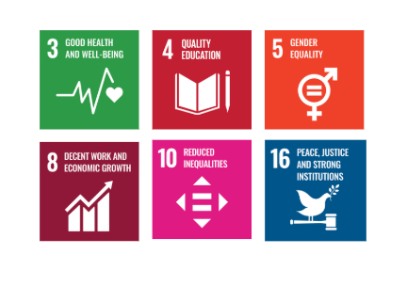

Responsibilities
- Senior Management: Ensure implementation of fair labor policies and allocate resources for employee well-being.
- Human Resources Team: Monitor labor conditions, oversee training programs, and address grievances.
- Operations & Manufacturing: Implement workplace safety and ethical labor standards.
- Supply Chain & Procurement: Ensure responsible sourcing and compliance with supplier labor policies.
- Employees: Adhere to workplace policies, report concerns, and participate in training initiatives.
- External Stakeholders: Support labor and human rights initiatives through responsible business practices.

Monitoring, Reporting, and Transperancy
Bally Fabs International Limited is committed to regularly monitoring its labor and human rights performance across key focus areas such as employee health and safety, working conditions, social dialogue, career management and training, prevention of child and forced labor, non-discrimination and harassment, and respect for external stakeholder human rights. Key Performance Indicators (KPIs) are established for each area and tracked through internal monitoring systems to evaluate progress against defined commitments. These KPIs are reviewed on a quarterly basis, and findings are consolidated into performance reports for senior management to guide strategic decision-making. Annual assessments capture achievements, identify gaps, and recommend corrective measures, while relevant outcomes are shared with stakeholders to promote transparency and accountability. All monitoring and reporting practices adhere to applicable labor laws, international conventions, and industry best practices, ensuring reliability, accuracy, and credibility in disclosures.

Review Mechanism
To ensure the effectiveness of Ballyfabs Int. Ltd.’s Labor & Human Rights Policy, a comprehensive review mechanism is in place involving regular assessments, updates, and stakeholder feedback, aligned with industry standards and regulations:
- The HR Manager annually reviews the policy to incorporate feedback and improvements.
- The Health and Safety Committee issues regular progress reports on quantitative targets.
- The Compliance Officer conducts external audits for transparency and accountability.

Amendment of Revision No. | Effective Date | Details of Amendment of Revision
00 | 01.01.2023 | New Policy Draft
01 | 01.01.2024 | Scope
01 | 01.01.2024 | Key Focus Areas
01 | 01.01.2024 | Review Mechanism
02 | 01.01.2025 | Key Focus Areas
02 | 01.01.2025 | Qualitative Objectives
02 | 01.01.2025 | Quantitative Targets & Target Year
02 | 01.01.2025 | Responsibilities
02 | 01.01.2025 | Alignment with the United Nations SDGs
02 | 01.01.2025 | Monitoring, Reporting, and Transparency

Effective Date | : 01.01.2025
Next Review Date | : 01.01.2026
Revision No. | : 02

Approved By :

Employee Acknowledgment Form
I, acknowledge that I have read, understood, and agree to adhere to the company’s Labor & Human Rights Policy. I recognize the importance of my role in supporting the company’s commitment to fair labor practices and am committed to actively participating in the implementation of this policy.
I will incorporate ethically responsible practices into my daily work, comply with labor regulations and company policies, and support continuous improvement of labor practices. I understand that my commitment is essential to achieving the company’s objectives and fostering a respectful workplace.

Employee Name | : _________________________
Employee ID | : _________________________
Department | : _________________________
Signature | : _________________________

